Critical Evaluation and Maintenance
Table of Contents
Intro 2
Data Corruption 2
Testing 3
A statistical solution 3
More integrity guarantees required 3
Technical debt 4
Message Persistence in Cloud Service (SQLite) 5
Testing 5
Fixing redundancy 5
ML-KEM implementation 6
Testing 6
Comparison of Performances 7
Comparison of Functionalities 8
Technical debt 9
Implementing the demo 10
Rich (https://github.com/textualize/rich) 10
Plotext (https://pypi.org/project/plotext/) 10
Testing the TUI 10
Technical debt 11
The monolithic architecture of main.py 11
Lack of thread-safety 11
Resolving the technical debt 11
The CI/CD Pipeline 13
The Monitoring System 13
Building the Deployment environment 14
Including Health checks for the Deployment 14

Intro
In this document we report the process of testing, reviewing, correcting and improving the baseline system. For every maintenance intervention we will explain how the problem was discovered and verified.
For every intervention we followed this approach:
- Assessing the problem.
- Implementing the feature/fix.
- Testing the new code against baseline tests to verify the preservation of legacy compatibility.
- Testing the new code against ad-hoc test.
- Documenting eventual technical debt.
- Producing a .patch file that shows the relevant changes (directory patches/).

Data Corruption
We noticed that the baseline system does not perform any kind of data integrity validation through the entire pipeline from the legacy sensor to the cloud service. This mean that the Cloud could end up receiving corrupted data (think about a sensor malfunction, a transmission problem or someone intentionally tampering with the transmitted data).
Then in order to end up filling the Cloud with unreliable data we need to solve the issue. The adopted strategy has been the following:
- Expand the functionalities of the Edge Gateway in order to drop the “bad packets”.
- Expand the functionalities of the Edge Gateway such that it is able to keep a log of the discarded packets.
- Expand the functionalities of the Cloud Service such that it can rise an alarm of some kind if it do not receive update from the sensor for a long time.

After implementing these changes we updated the test suite accordingly. test_baseline.py has been updated in only to test only the “happy paths”, i.e. all the cases in which the packets are properly composed. It has been created a new test suite: test_failure_handling.py that instead only verifies the handling of corrupted packets.

Testing

A statistical solution
While running the test suite we discovered that some malformed packets are still able to slip through. This happen because the legacy system relies on AES-CBC that does not provide any integrity guarantees. Since the Sensor is a legacy system and we cannot apply fixes here, we must surrender to the idea that fixing this issue is impossible. However we can mitigate it as follow:
First of all we can make the validation performed by the gateway more strict in this way: instead checking only that the temperature is a float as the current implementation does we can enforce a regex. Another measure to reduce the probability that malformed records goes throw is to verify that the timestamp falls in a certain interval of time. These measures won't catch corruption where 17.5flips to 16.5 but will drastically reduce the number of undetected corruptions. Then since have a 100% success rate is not feasible we must set a threshold for our tests. We say that we are satisfied (our test passes) if the system catches 80% of the malformed packets.

While conducting further tests we also notice that the probability of a message of passing through depends also on the admitted time interval of the Edge Gateway, tighter is the interval, more probable is to spot corrupted package, if the interval is too tight good packets may be discarded.

Finally to ensure the threshold is respected we made the test suite run about 100 times to ensure as much statistical coverage as possible.

More integrity guarantees required
Since now we have talked only about the communication between the Sensor and the Gateway, now it is time to take into account also the path between the Gateway and the Cloud Service.
As first implementation to enforce integrity guarantees between the Gateway and the Cloud we used CR32 checksum. The problem is that this approach ensure integrity only against accidental data corruption (e.g. network errors and interferences) and then it is not a good method to enforce integrity when for what concern intentional data tampering.
For this reason the AES-CBC mechanism previously used has been substituted with an authenticated mode of encryption: AES-GCM in order to ensure both confidentiality and integrity.

Technical debt
Since the Communication between The sensor and the Gateway still relies on AES-CBC in this part of the system the information may be subject to tampering or networks error, this represent an integirity problem, that cannot be solved unless the Sensor itself is replaced.

Details can be seen in:
- patches/AES_GCM_between_edge_gateway_and_cloud.patch
- patches/data_corruption_handling_sensor_to_Gateway.patch

Message Persistence in Cloud Service (SQLite)
The Cloud Service in the baseline system do not act like a real cloud, in the sense that currently it lacks the core feature of a cloud service that is the persistent memorization of the information.
Sensor telemetry must be reliably stored in a database for historical queries, analytics, and audits.
To solve this issue, the adopted strategy has been the following:
- Introduce persistent storage into the CloudService component using Python's built-in sqlite3 library (requiring zero external dependencies to keep the architecture simple).
- Automatically generate a database table (messages) upon service initialization to store the temperature, timestamp, and original raw message.
- Ensure that the save_message() function is only triggered after successful AES-GCM decryption and strict semantic validation, guaranteeing that only healthy data is ever stored.

Testing
After implementing the persistent storage, we expanded our testing coverage. A dedicated automated test (test_cloud_database_persistence) was added to verify the correct insertion of records in the database. This test verifies the correct creation of the table schema and data types. More importantly, it asserts that the Cloud Service completely rejects malformed payloads and refuses to execute the SQL insertion, proving that our database is entirely immune to poisoning from transit corruption or sensor malfunctions. It also verified the end-to-end integration: simulating a legacy sensor reading that successfully traverses the Edge Gateway, gets verified by the Cloud, and finally rests securely in the SQLite database.

Fixing redundancy
During a subsequent static code review, we identified significant operational redundancy within the SQLite integration. Specifically, the data parsing and schema generation logic were being duplicated on every transaction. We refactored this segment to streamline the data pipeline, eliminating the redundant operations and keeping the entire code base cleaner.

Details can be seen in:
- patches/sqlite_message_persistence_cloud_service.patch
- patches/db_redundancy.patch

ML-KEM implementation
We integrate PQC measure by adopting an hybrid scheme with the DH key exchange already in place. In this way we followed the best-practice standard for the implementation of modern PQC.

The ML-KEM implementation implied several changes and addition to out baseline system that we are going to document here:

First of all we needed to find a library that implements ML-KM, this approach is the best in terms of security since try to write a cryptographic library from scratch is extremely error-prone and would expose the system to severe vulnerabilities, the we relied on the mlkem Python package that provided us the official FIPS 203 ML-KEM specification.
As second step we modernized the Cloud Service (cloudservice.py) to handle the new hybrid protocol. We had to change the signature of the legacy method negotiate_dh() to negotiate_session() in order to avoid ambiguities and accommodate the new parameters (the ML-KEM encapsulation key). The method now:
- Compute the DH shared secret.
- Performs ML-KEM encapsulation to generate the ML-KEM shared secret an chipertext.
- Derives the final AES-GCM key by concatenating the DH shared secret and the ML-KEM shared secret via SHA-256.
The third step of this phase was the modernization of the Ege Gateway (edge_gateway.py). We modified the method negotiateSession to initiate the hybrid protocol that now:
- Generates the ML-KEM encapsulation/decapsulation keys.
- Generates the DH keys.
- Send the keys to the Cloud Service.
- Performs decapsulation upon receiving the ML-KEM cipher text.
- Mixes the retrived ML-KEM secret with the classic DH secret to derive the identical AES-GCM key.

Testing
The previous tests passed flawlessly, then the regression test was successful, we introduced another test suite (test_mlkem.py) just to test the basic functionality of the adopted library (it does not invoke any method of the system).
We needed to update the baseline test suite. It was considering only the DH key exchange in the measuring of the metrics, from now on it consider also the metrics of ML-KEM.

Comparison of Performances
These are the metrics from the baseline System
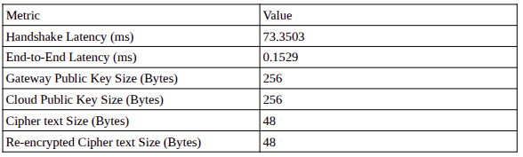
These are the same metrics with the introduction of the Hybrid Scheme (ML-KEM + DH):
Metric | Value
Handshake Latency (ms) | 75.8205
End-to-End Latency (ms) | 8.1892
Gateway DH Puclic Key Size (Bytes) | 256
Gateway ML-KEM EK Size (Bytes) | 1184
Gateway Total Payload Size (Bytes) | 1440
Cloud DH PK Size (Bytes) | 256
Cloud ML-KEM CT Size (Bytes) | 1088
Cloud Total Payload Size (Bytes) | 1344
Ciphertext Size (Bytes) | 32
Re-Encrypted Ciphertext Size (Bytes) | 43

→ EK stands for (Encapsulation key), it is the conceptual “Public key” of the ML-KEM key agreement. It is the key sent to Cloud.
→ CT The encrypted packet that the Cloud send to the Gateway once it received the EK.
→ The Gateway’s payload consists of both its DH Public Key + the ML-KEM EK. The Cloud’s payload consists of its DH Public Key + the ML-KEM CT.
→ Ciphertext Size is the size of the packets that travel between the sensor and the Edge Gateway.
→ Re-Encrypted Ciphertext is the size of packets that travel between the Edge Gateway and the Cloud Service.

Comparison of Functionalities
Here we just see a comparison on “how the system works” before and after the introduction of the Hybrid scheme:
Before: same diagram of the document Baseline analysis – Initial architecture
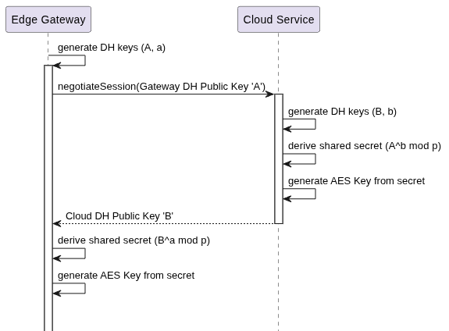
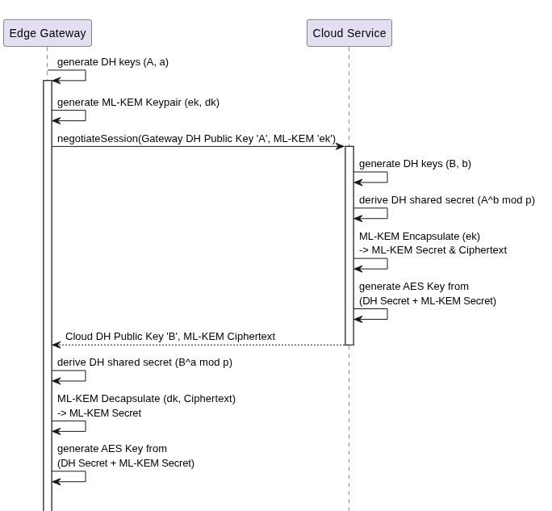
After: Corresponding execution flow after the introduction of the Hybrid scheme:

Details can be seen in:
- patches/ML_KEM_integration.patch

Technical debt
The entire key exchange remain non-authenticated, the system lacks any form of Public Key Infrastructure and digital signatures, then it is vulnerable to Man-In-The-Middle attacks in both directions: Gateway to Cloud and Clod to Gateway. Then an attacker that gest the public parameters is able to impersonate both ends of the communication.

Implementing the demo
In order to showcase the functionality of the system in real-time, we implemented a multi-threaded architecture with a live dashboard.
The demo utilizes three background threads running concurrently.
- The first thread runs the legacy Sensor, which continuously generates and buffers telemetry data.
- The second thread runs the Edge Gateway, which is responsible for fetching the data from the Sensor's buffer and securely forwarding it.
- The third thread runs the Cloud Service, which decrypts the incoming payloads and updates global statistical metrics.
Finally, the main thread manages a TUI (Terminal User Interface). The TUI visualizes the pipeline's operation by displaying a live temperature graph, a log of incoming data, computed statistics, and a visual alarm that triggers if the sensor drops offline.
In order to construct the TUI we added the following new dependencies to the code:

Rich (https://github.com/textualize/rich)
It is used to manage the layouts, panels and the updating of the terminal screen. It is a library used to format the terminal, makes easy to add color, bars and tables.

Plotext (https://pypi.org/project/plotext/)
It is used to generate the graph. It is a library that allows for scatter, line, bar, histograms and date-time plots.

Testing the TUI
While letting run the GUI we noticed that, when simulating on purpose a system failure (setting corruption_probability or failure_probability to 1) the TUI stayed simply quiet without reporting anything. This is not the intended behavior because while developing previous part of the system (the Cloud Service) we designed the system to signal if something was broken.

The problem was due to the fact that the thread running the cloud was not considering the function sensor_health() to check the state of the connection.

Technical debt
We have identified several possible issue in introducing this demo:

The monolithic architecture of main.py
Since all of this has the only purpose to showcase the functionality of the system we overlooked the separation of concern among different components. This resulted in having the main.py artifacts that does a lot of stuff: it has logic necessary to the key negotiation, logic to manage the thread and moreover it contains logic related to the TUI.
This is a well-known anti-pattern. Already in this state the artifact is difficult to read and maintain, if more functionalities are added to the TUI without addressing this problem first the codebase will end-up having an unreadable bottleneck.
It is a best practice that the UI logic is keept separated from the rest of the code.

Lack of thread-safety
The components of the system communicate with the TUI via global variables and there is no lock mechanism on these data structures. Then multiple threads have concurrent access to the same data structure. Since our system is pretty simple we do experience race conditions but in a more complex system this could result in a problem. For instance, if the same TUI needs to take into account data from different sensors the chronological order of the data may not be respected at all. To solve this a lock mechanism should be introduced.
This problem in theory is also present for what concern the exchange of packets between the three components of the system, but in this case since the system is properly synchronized via hard-coded time intervals (another very bad practice), the problem is no present.
Details can be seen in:
- patches/TUI_Implementation.patch

Resolving the technical debt
While proceeding with the works, during the enhancing of the CI/CD pipeline (see the next section of this document for details). We made the decision to completely remove the TUI from the codebase . While it was useful as brief demo for visualizing the execution flow of the system, it introduces too much complexity to be efficiently handled and maintained, moreover, most of the job of the TUI is done by the monitoring system we implemented (see the next section of this documents for details). The removed the TUI, and consequentially solved great part of the technical debt in the following way:
- We removed the rich and plotext dependencies, drastically reducing the application's footprint and simplifying the Docker container.
- We stripped out the global data buffers, layout logic, and the UI rendering loop, neutralizing the first thread-safety risks analyzed in the section: “The monolithic architecture of main.py”
- We introduced Python's standard logging module to allow the application to run silently in the background, outputting structured logs to standard output.
Moreover in this way we also end-up with cleaner and readable code.
Details can be seen in:
- patches/removing_the_TUI.patch

The CI/CD Pipeline
The starting point for enhancing the CI/CD pipeline is the baseline system where we had a mock pipeline that just execute the tests and has a placeholder for the docker orchestration we aim to generate. While in the previous task we already set up an initial docker environment to run the demo of the system here we are going to add the live monitoring system, fix eventual issue with the deployment and the docker orchestration.

The Monitoring System
For the monitoring system we relied on Prometheus, an open source monitoring and alerting toolkit.
After importing the library in our main.py we defined three specific metrics:
sdmo_packets_total
This is a counter that racks the number of packets that have reached the Cloud Service. In Prometheus this data type can only go up and it is useful for an eventual operation team to measure the throughput of the system.
sdmo_temperature_celsius
This metric tacks the live temperature reading currently being processed by the system, the type of data used here is the Gauge. Differently from the counter this kind of data can go up and down.
sdmo_errors_total
This is another counter that acts as an health indicator, It increments every time the Cloud Service detects a failure (i.e. it does not receive packets for long time). This metric is useful because it can be used to launch automated alerts.

These metrics are exposed on an HTTP server that is opened on the port 8000 running in the background of the main thread. Then the metrics can now be seen on localhost:8000/metrics. The output is not intended for humans, we are going to address this problem in the next section.
Details can be seen in:
- patches/Prometheus_initial_implementation.patch

Building the Deployment environment
In order to build the deployment environment we are relying on Docker Compose. We will simply add one more container to our current deployment architecture. Up to now we have worked only with a single container that runs the application. In order to integrate properly the monitoring system we will spin up another container that is responsible for running the the Prometheus monitoring server. The two containers will then talk to each other and Prometheus will be then able to show the metrics in an human-readable format useful for actively monitoring the system.
So, first of all, we create a configuration file for Prometheus (prometheus.yml) that specify to the Prometheus instance where to look for metrics (the “sdmo app” on the port 8000).
Secondly we create the docker compose file (docker-compose.yml) that is the core of our deployment that defines the two services.
With this system now we should have a working system, with a monitoring-system that is actually something human-readable, indeed the Prometheus dashboard for the monitoring can be seen at localhost:9090.
Details can be seen in:
- patches/Deployment_Environment.patch

Including Health checks for the Deployment
Now comes the moment to improve our CI/CD pipeline with some health checks. Currently the pipeline (ci.yml) tries to execute the tests and just have a placeholder for the docker orchestration we implemented in the previous step. However just because our containers are running this does not mean that the application inside it is working. Indeed the tests could pass and the docker orchestration may also build flawlessly but what happens if the whole system enter some sort of infinite loop that we did not spot before or remains blocked for other reasons? To solve this we will rely on a “health check” previously putted in out docker compose configuration that the CI/CD pipeline will use to know the status of the application.
It works as follows:
Every ten seconds the application tries to fetch the metrics from the Prometheus metrics page, if the Python application is running correctly the Prometheus client will respond with an HTTP 200 OK message. When this message is sent then the application is considered “healthy”. This message exchange is tried three times before the application is considered “unhealthy”, i.e. broken.
Then, with this extra check, the GitHub action will fail not only when the test suite will fail, but also when there are problems in the deployment, effectively protecting the main branch.

The following diagram, show the interaction between the two containers, and how the browser visualize the data from the monitoring system.
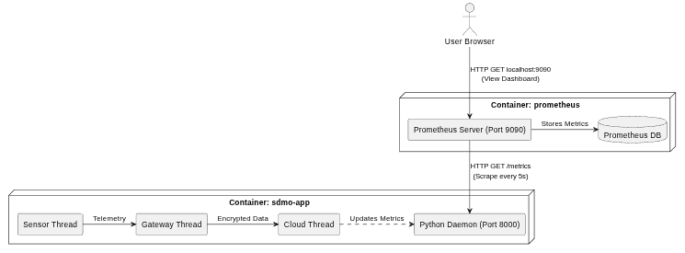
Details can be seen in:
- patches/Deployment_Environment.patch

Fixing Docker Volumes
Currently, the SQLite database and Gateway logs generated by the system are stored inside the ephemeral Docker container. Then all the data produced by the application are deleted when the container dies.
To make this a true production-ready architecture, we need to map those directories out to your host machine using Docker Volumes.
In this way the logs of the Edge Gateway will be returned, and in case of eventual transmission failures, these can be used to address eventual problems and the SQLite database build by the Cloud Service is stored on the machine that execute the application, in this way further analysis on the produced data are possible.
Details can be seen in:
- patches/Docker_Volumes.patch

